|  |
| --- |
|  |
| 新概念 3 册 |
| Lesson41 Illusions of pastoral peace |

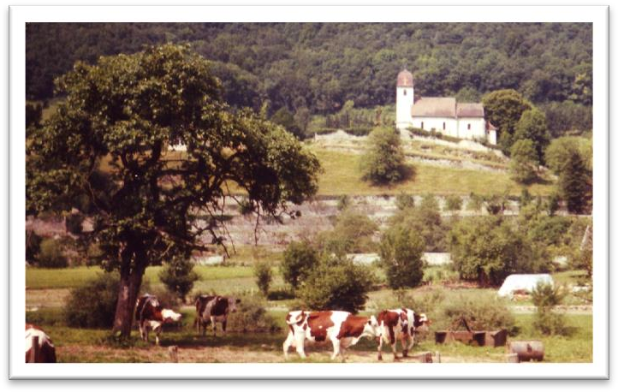

Book

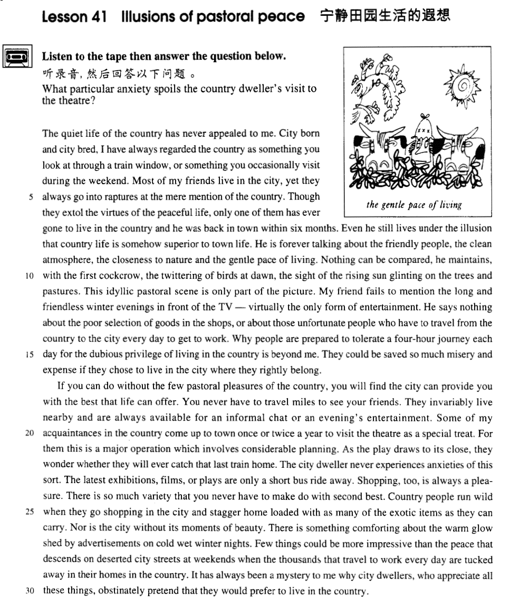

课文

The quiet life of the country has never appealed to me.

宁静的乡村生活从来没有吸引过我。

City born and city bred, I have always regarded the country as something you look at through a train window, or something you occasionally visit during the weekend.

我生在城市，长在城市，总认为乡村是透过火车车窗看到的那个样了，或偶尔周末去游玩一下景象。

Most of my friends live in the city, yet they always go into raptures at the mere mention of the country.

我的许多朋友都住在城市，但他们只要一提起乡村，马上就会变得欣喜若狂。

Though they extol the virtues of the peaceful life, only one of them has ever gone to live in the country and he was back in town within six months.

尽管他们都交口称赞宁静的乡村生活的种种优点，但其中只有一个人真去农村住过，而且不足6个月就回来了。

Even he still lives under the illusion that country life is somehow superior to town life.

即使他也仍存有幻觉，好像乡村生活就是比城市生活优越。

He is forever talking about the friendly people, the clean atmosphere, the closeness to nature and the gentle pace of living.

他滔滔不绝地大谈友好的农民，洁净的空气，贴近大自然的环境和悠闲的生活节奏。

Nothing can be compared, he maintains, with the first cockcrow, the twittering of birds at dawn, the sight of the rising sun glinting on the trees and pastures.

他坚持认为，凌晨雄鸡第一声啼叫，黎明时分小鸟吱喳欢叫，冉冉升起的朝阳染红树木、牧场，此番美景无与伦比。

This idyllic pastoral scene is only part of the picture.

但这种田园诗般的乡村风光仅仅是一个侧面。

My friend fails to mention the long and friendless winter evenings in front of the TV -- virtually the only form of entertainment.

我的朋友没有提到在电视机前度过的漫长寂寞的冬夜--电视是唯一的娱乐形式。

He says nothing about the poor selection of goods in the shops, or about those unfortunate people who have to travel from the country to the city every day to get to work.

他也不说商店货物品种单调，以及那些每天不得不从乡下赶到城里工作的不幸的人们。

Why people are prepared to tolerate a four-hour journey each day for the dubious privilege of living in the country is beyond me.

人们为什么情愿每天在路上奔波4个小时去换取值得怀疑的乡间的优点，我是无法理解的。

They could be saved so much misery and expense if they chose to live in the city where they rightly belong.

要是他们愿意住在本来属于他们的城市，则可以让他们省去诸多不便与节约大量开支。

If you can do without the few pastoral pleasures of the country, you will find the city can provide you with the best that life can offer.

如果你愿舍弃乡下生活那一点点乐趣的话，那么你会发出城市可以为你提供生活最美好的东西。

You never have to travel miles to see your friends.

你去看朋友根本不用跋涉好几英里，

They invariably live nearby and are always available for an informal chat or an evening's entertainment.

因为他们都住在附近，你随时可以同他们聊天或在晚上一起娱乐。

Some of my acquaintances in the country come up to town once or twice a year to visit the theatre as a special treat.

我在乡村有一些熟人，他们每年进城来看一回或几回戏，并把此看作一种特殊的享受。

For them this is a major operation which involves considerable planning.

看戏在他们是件大事，需要精心计划。

As the play draws to its close, they wonder whether they will ever catch that last train home.

当戏快演完时，他们又为是否能赶上末班火车回家而犯愁。

The city dweller never experiences anxieties of this sort.

这种焦虑，城里人是从未体验过的。

The latest exhibitions, films, or plays are only a short bus ride away.

坐公共汽车几站路，就可看到最新的展览、电影、戏剧。

Shopping, too, is always a pleasure.

买东西也是一种乐趣。

There is so much variety that you never have to make do with second best.

物品种繁多，从来不必用二等品来凑合。

Country people run wild when they go shopping in the city and stagger home loaded with as many of the exotic items as they can carry.

乡里人进城采购欣喜若狂，每次回家时都买足了外来商品，直到拿不动方才罢休，连走路都摇摇晃晃的。

Nor is the city without its moments of beauty.

城市也并非没有良辰美景。

There is something comforting about the warm glow shed by advertisements on cold wet winter nights.

寒冷潮湿的冬夜里，广告灯箱发出的暖光，会给人某种安慰。

Few things could be more impressive than the peace that descends on deserted city streets at weekends when the thousands that travel to work every day are tucked away in their homes in the country.

周末，空旷的街市笼罩着一种宁静气氛，没有什么能比此时的宁静更令人难忘了。当成千上万进城上班的人回到他们的乡间寓所之后，

It has always been a mystery to me why city dwellers, who appreciate all these things, obstinately pretend that they would prefer to live in the country.

城里人对这一切心里很明白，却偏要执拗地装出他们喜欢住在乡村的样子，这对我来说一直是个谜。

词汇讲解

* **illusion** [ɪ'lu:ʒn] n. 错觉

**illusion** / **delusion**

**be / live under the illusion / delusion that …** 有某种错觉

* He **is / lives** under the **illusion / delusion** that he is always right.

**【近义词组】**表达**“错觉”**：

**be under the impression that …**

* Though the crew **were at first under the impression that** the lost ship had been found, the contents of the chest proved them wrong.
* **breed [bri:d]v. 养育，培育**

**breed** **bred**（过去式） **bred** （过去分词）

a **well-bred** child 有教养的；良种的；受过良好教育的

an **ill-bred** child 粗鲁的；没礼貌的；（尤指）没教养的

**born and bred** （在某地）出生长大；受过 … 薰陶

* I was **born and bred** in China.
* I was China **born and bred**.
* I was city **born and bred**.
* I was country **born and bred**.

**【近义词组】**表达**“养大”**：

**bring up sb.**

**raise sb.**

**rear sb.**

* **rapture** ['ræptʃə(r)]n. 极度的高兴，狂喜

**程度从大到小：**

**rapture** **>** **delight** **>** **joy** / **happiness**

**be in raptures / go into raptures *about* / *over* / *at* sth.** 对某事欣喜若狂

* She **was in** / **went into** **raptures** **about** her new house.
* **extol** [ɪk'stəʊl]v. 高度赞扬，盛赞

**extol the virtues / benefits of sth.** 盛赞某事…

* He **extolled the virtues of** Internet technology.

**【近义词组】**表达**“ 赞扬** **”**：

**exalt** 表扬；褒扬；高度赞扬

**eulogize** 称赞；颂扬；赞颂

**praise** 赞扬；称赞；赞美

**acclaim** [usually passive] 公开称誉某人/某事物（为 … ）；给予高度评价

* a much-acclaimed novel

**compliment** 赞扬；称赞

**compliment sb. on sth.**

* Everyone at the party **complimented** Mary **on her** new dress.
* **superior** [su:'pɪəriə(r)]adj. 优越的，优秀的，高级的（没有比较级和最高级）
* He is a **superior** actor.

**be superior to …** 比…高级、优越

* Your computer **is far superior to** mine.

**【反义词】**

**inferior** 较差的；次的；比不上 … 的

**be inferior to …**比…差

**【相关词组】**

**senior** 级别（或地位）高的

**be senior to …**

**junior** 地位（或职位、级别）低下的

**be junior to …**

**prior** 先前的；较早的；在前的

**be prior to …**

**posterior** 在后面的；在后部的

**be posterior to …**

* **cockcrow** ['kɒkkrəʊ]n. 鸡啼，公鸡打鸣

**cockcrow** 黎明；鸡叫，公鸡的啼叫

**cockroach** 蟑螂

* Many girls are **afraid / scared / frightened** of **cockroaches**.

**【相关词组】**表达**“ 动物叫** **”**：

**crow** 像雄鸡的）啼叫声，喔喔叫声

**cackle** 咯咯叫

**quack** （鸭子的）呱呱声，嘎嘎声

**meow** （猫叫声）喵

**bark** （狗等的）吠声，嗥叫声

**bleat** 咩咩叫

**bellow** （公牛等）吼叫

**grunt** （动物，尤指猪）发出呼噜声

**neigh** （马）嘶鸣

**roar** （狮虎…）吼叫；咆哮

**chirp**  （小鸟或某些昆虫) 吱喳叫；唧唧叫；发啁啾声

**twitter** （鸟）唧啾，吱喳，啁啾

**warble** （鸟）啭鸣

* **glint** [glɪnt]v. 闪烁 （碎碎的亮点闪烁）
* The dewdrops **glint** in the sunshine.

**【近义词组】**表达**“ 闪烁”**：

**sparkle** 闪烁；闪耀（碎碎的亮点闪烁）

**glitter** 闪亮；闪耀；光彩夺目

* All that **glitters** is not gold.

**flicker** （灯光或火焰)  闪烁；闪现；忽隐忽现；摇曳

**flash** （强光）闪光；闪耀

**twinkle** （星光）闪耀；闪烁

* **Twinkle**, **twinkle**, little star, like a diamond in the sky.

**glow** （尤指热或微温的物体) 发出微弱而稳定的光；发出暗淡的光

* The heated iron bar **glowed**.
* **descend** [dɪ'send]v. 下降，降临
* We **descended** the stairs. （及物）
* The plane started to **descend**. （不及物）

**【反义词】**

**ascend** 上升；升高；登高

**【派生】**

**be descended from …**  是…的后代

**descendant** n. 后裔；后代；子孙

* He **is descended from** Confucius.
* He is a **descendant** of Confucius.

**descend on / upon …** 1.（主语是人）突然大批来访；2.（主语是物）（夜晚、黑暗、情绪等) 降临；来临

* Millions of tourists **descend on** Beijing every year.（突然大批来访）
* Total silence **descended on** the room.（降临；来临）
* A sense of complete helplessness had **descended upon** him..（降临；来临）
* A double blessing has **descended upon** the house. （降临；来临）
* Few things could be more impressive than the peace that **descends on**（降临） deserted city streets at weekends when the thousands that travel to work every day are tucked away in their homes in the country.
* **obstinately** ['ɒbstɪnətlɪ]v. 顽固地，固执地
* The old man is **as obstinate as** a mule.

**【扩展】**

* **as stupid as a donkey** 蠢的像驴
* **as busy as a bee** 勤劳的像蜜蜂
* **as cunning as a fox**  像狐狸一样狡猾
* **as brave as a lion** 勇敢的像狮子
* **as proud as a peacock**  骄傲的像孔雀
* **as poor as a church mouse** 穷的像教堂里的老鼠
* **as graceful as a swan** 像天鹅一样优美

**【近义词组】**表达“ 固执地”：

**stubborn** 固执的；执拗的；顽固的；倔强的

**headstrong** 固执的；倔强任性的

**determined** 坚定的；坚决的；果断的

**resolute** 坚决的；有决心的

课文讲解

# （第一段）

# The quiet life of the country has never appealed to me.

知识点（1） 复习

**appeal to sb.** 吸引某人

* The idea never **appealed to me** very much, but one day, after a heavy shower, I happened to be walking in my garden when I noticed a huge number of snails taking a stroll on some of my prize plants.

**appeal** n.吸引力；感染力；魅力

* In spite of national differences, certain funny situations have a universal **appeal**.

**【近义词组】**表达“吸引某人”：

* The quiet life of the country has never **attracted** me.
* The quiet life of the country has never **intrigued** me.
* The quiet life of the country is not **my cup of tea**.

# City born and city bred, I have always regarded the country as something you look at through a train window, or something you occasionally visit during the weekend.

**语法分析:**

City born and city bred（非谓语动词引导原因状语), I have always regarded the country as something you look at through a train window（定语从句，省略关系词that）, or something you occasionally visit during the weekend（定语从句，省略关系词that）.

知识点（1） 非谓语动词做原因状语

* **课文写法替换：**
* **Because / Since I was** born and bred in the city, …（不如课文简洁）
* **Because / Since I was** city born and bred, …（不如课文简洁）

知识点（2） 复习

**regarded A as B** 把A看作B

* **课文写法替换：**
* …, I have always **thought of** the country **as** something …
* …, I have always **considered** the country something …

知识点（3）

表达 “对某事不太了解”：

I **have no intimate knowledge of** the country.

# Most of my friends live in the city, yet they always go into raptures at the mere mention of the country.

**语法分析:**

Most of my friends live in the city, yet（连词，“然而”） they always go into raptures at the mere mention of the country（时间状语）.

知识点（1）

**go into raptures** 欣喜若狂、手舞足蹈

= **go into ecstasies**

知识点（2） Lesson23

**at the … of** 一……就……

* On the other hand, your stomach would turn **at the idea of** frying potatoes in animal fat, …
* It is true that during their explorations they often faced difficulties and dangers of the most perilous nature, equipped in a manner which would make a modern climber shudder **at the thought**, …
* **课文写法替换：**
* … as soon as they **speak of / mention** the country.
* … **immediately / directly** they **speak of / mention** the country.
* … **the moment** they **speak of / mention** the country.

# Though they extol the virtues of the peaceful life, only one of them has ever gone to live in the country and he was back in town within six months.

**语法分析:**

**Though** they extol the virtues of the peaceful life（让步状语从句）, only one of them has ever gone to live in the country and he was back in town within six months.

知识点（1）（见词汇讲解）

**extol the virtues / benefits of sth.** 盛赞某事…

知识点（2）

* **课文写法替换：**
* … only one of them **has personal experience of living** in the country.

Most of them are mere talkers. 多数人都是空谈着

# Even he still lives under the illusion that country life is somehow superior to town life.

**语法分析:**

Even he still lives under the illusion **that** country life is somehow superior to town life（同位语从句）.

知识点（1）

**be / live under the illusion / delusion that …** 有某种错觉

* **课文写法替换：**
* Even he **is** still under the illusion that …
* The worst thing about the do-it-yourself game is that sometimes even men **live under the delusion** that they can do anything, even when they have been repeatedly proved wrong.

知识点（2）

**be superior to …** 比…高级、优越

* **课文写法替换：**
* … town life **is** somehow **inferior to** country life.（反义表达）
* …country life somehow **beats** town life.
* …country life somehow **has an advantage over** town life.

# He is forever talking about the friendly people, the clean atmosphere, the closeness to nature and the gentle pace of living.

知识点（1） Lesson2

**be forever doing sth.** 总是做某事（贬义）

= **be always doing sth.**

* Our vicar **is always raising money** for one cause or another, but he has never managed to get enough money to have the church clock repaired.

**【近义词组】**表达“总是做某事”：

**be constantly / continually doing sth.**

**keep (on) doing sth.**

**do sth. all the time**

知识点（2）【课文仿写】

* **造句：**他总是不停地谈论友好的人民，干净的空气，蔚蓝的 (azure) 天空和廉价的商品。
* He is forever talking about the friendly people, the clean atmosphere, the azure sky and the cheap commodities.

# Nothing can be compared, he maintains, with the first cockcrow, the twittering of birds at dawn, the sight of the rising sun glinting on the trees and pastures.

知识点（1）

**compare A with / to B** 把A和B相比较

* I hate the way you always **compare** me **with** your ex-boyfriend.

**nothing can be compared with …** （表最高级的含义）没有与之相比

* **造句**：泰山日出的美景是无以伦比的。
* **Nothing can be compared with** the sight of the rising sun glinting on Mount Tai.

**【扩展】**

**compared to / with …** 与…相比

* **Compared to** our small flat, Bill’s house seemed like a palace.

**in / by contrast to / with …**与…相比

* **In contrast to** the hot days, the nights are bitterly cold.

**in / by comparison to / with …** 与…相比

* People who do manual work often receive far more money **in comparison with** people who work in offices.

知识点（2）

**at dawn** 在黎鸣，破晓，（时间段，介词at）

= **at the break / crack of dawn**

= **at sunrise**

= **at daybreak**

**from dawn to dusk** 从早到晚

**【反义词】**

**at dusk / at sunset** 在日暮、在黄昏

# This idyllic pastoral scene is only part of the picture.

知识点（1） Lesson35

**语法：**当 **“part of”** 之前没有形容词修饰时，通常不加不定冠词 **“a”**

* **Part of** the building was destroyed in the fire.
* Falling over is **part of** learning how to ski.
* This idyllic pastoral scene is only **part of** the picture.
* Justice is **part of** the complex machinery of the law.
* Memory loss is **a *normal* part** of the aging process.
* … so vast is the number of planets, that intelligent life is bound to be **a *natural* part of** the universe.

# My friend fails to mention the long and friendless winter evenings in front of the TV -- virtually the only form of entertainment.

**语法分析:**

My friend fails to mention the long and friendless winter evenings in front of the TV ― virtually the only form of entertainment（TV的同位语）.

知识点（1）【课文仿写】

* **造句:** 这个房地产经纪人 (real estate agent) 根本就没提在崎岖的 (rough) 乡间道路上又闷又挤的 (stuffy and packed) 小公共汽车 (minibus)，而这几乎是唯一的交通方式。
* The real estate agent failed to mention the stuffy and packed minibuses on rough country roads—virtually the only form of transportation.

# He says nothing about the poor selection of goods in the shops, or about those unfortunate people who have to travel from the country to the city every day to get to work.

**语法分析:**

He says nothing **about** the poor selection of goods in the shops, or **about** those unfortunate **people** who have to travel from the country to the city every day to get to work（who...定语从句，修饰**people**）.

知识点（1）

**every day** （分开写，副词短语）

**everyday** adj. 每天的；每日发生的；日常的

* **everyday** life
* **everyday** necessities

# Why people are prepared to tolerate a four-hour journey each day for the dubious privilege of living in the country is beyond me.

**语法分析:**

**Why** people are prepared to tolerate a four-hour journey each day ***for*** *the dubious privilege* ***of*** *living in the country（of…后置定语,修饰privilege）*  （***for***... 目的状语）（**Why**...主语从句）is beyond me.

知识点（1）

**be prepare to do** 乐意做某事

**be prepare for** 准备好做某事

知识点（2） Lesson4

privilege

* Such is human nature, that a great many people are often willing to sacrifice higher pay for the **privilege of** becoming white-collar workers.

知识点（3）

**be beyond sb.** 某人无法理解

= **be a mystery to sb.**

* It has always been **a mystery to me** why city dwellers, who appreciate all these things, obstinately pretend that they would prefer to live in the country.

**beat sb.** 某人无法理解

* It **is beyond me why** …
* It **is a mystery to me why** …
* It **beats me** why …

知识点（4）

写作：课文没有用形式主语句式；在上下文中让句式富于变化

* 第1句： He says nothing about ...（主句开头）
* 第2句： Why people are prepared to tolerate a four-hour journey each day for the dubious privilege of living in the country ... （主语从句）
* 第3句：They could be saved ... （主句开头）

知识点（5）【课文仿写】

* **造句**: 我无法理解为什么人们愿意 (be prepared to do) 放弃更高的薪水而为了可疑的(dubious) 成为白领工人的所谓特权。
* Why people are prepared to sacrifice higher pay for the dubious privilege of becoming white-collar workers is beyond me.

# They could be saved so much misery and expense if they chose to live in the city where they rightly belong.

**语法分析:**

They could（虚拟条件句） be saved so much misery and expense **if** they chose（虚拟条件句） to live in the city *where they rightly belong（where...定语从句，修饰）*. （**if**... 条件状语从句）

知识点（1）

**save sb. sth. / doing sth.** 使某人免于做某事

* If you lend me some money, it will **save me a trip** to the bank.
* If you tell her the news, it will **save me calling her**.

知识点（2）

**rightly** adv. for a good reason 理所应当的

* It was a vicious foul, and the referee **rightly** removed him from the game.
* A lot of people round here were furious, and **rightly** so.

知识点（3）

… where they rightly belong. （belong不及物）

… **which** they rightly **belong to**. 如果换成belong to缺少宾语，关系代词做宾语换成which

知识点（4）【课文仿写】

* **造句：**他们可以省去诸多痛苦、不便和无尽的怀旧之情 (nostalgia)，如果他们选择住在他们本应属于的国度 (land)。
* They could be saved so much misery, inconvenience and endless nostalgia if they chose to live in the land where they rightly belong.

# （第二段）

# If you can do without the few pastoral pleasures of the country, you will find the city can provide you with the best that life can offer.

**语法分析:**

If you can do without the few pastoral pleasures of the country（条件状语从句）, you will find *the city can provide you with the best* ***that*** *life can offer（****that*** *...定语从句，修饰the best）*. （宾语从句，省略关系词）

知识点（1）

**do without sth.** 没有…也行

* If you need my car, I can **do without** it today.
* She **can’t do without** candy.

**【近义词组】**表达“没有…也行”：

**go without sth.**

**manage without sth.**

知识点（2）

**provide sb. with sth.**  为某人提供某事

= **provide sth. for sb.** 为某人提供某事

# You never have to travel miles to see your friends.

# They invariably live nearby and are always available for an informal chat or an evening's entertainment.

知识点（1） 表达“在附近”

* **课文写法替换：**
* They invariably live **in the** **neighborhood** / **vicinity** …

知识点（2）

**be available / free + *for sth.* / *to do sth.*** 有空做某事

* My professor **is** always **available** **for a conversation** / **to talk** with his students.

**【相关词组】【反义】**表达“没空”：

**be busy**

**be not available**

**be tied up**

**have a previous / prior engagement**

* I appreciate your kind invitation, but **I have a previous / prior engagement**.

知识点（3）

**chat / chit-chat** 聊天

# Some of my acquaintances in the country come up to town once or twice a year to visit the theatre as a special treat.

知识点（1）

go **up** to the city （“**up**”表示更重要的）

go **down** to the country （“**down**”表示次要的）

They walked **up** north. 北上

They walked **down** south. 南下

They sailed **up** the river.

They sailed **down** the river.

知识点（2）

**treat** n. 难得的乐事

**be a real / great treat** 难得的事、开心的事

* When we were kids, a trip to the beach **was a real treat**.
* Her son's visits **are a great treat** for her.

**as a special treat** 作为一件难得的事

* We took the kids to the zoo **as a special treat**.

# For them this is a major operation which involves considerable planning.

知识点（1）

**major**: important; significant 重要的、重大的

**【反义】**

**minor**

**unimportant**

**trivial**

**insignificant**

知识点（2）Lesson32

**operation**: work; activity; action 行动、工作、活动

* The **salvage operation** had been a complete failure.
* rescue **operation** 营救行动
* relief **operation** 救济工作
* cleanup **operation** 大扫除

知识点（3）复习

**语法**：定语充当并列句

* … which involves considerable planning.
* … and it involves considerable planning.

知识点（4）【课文仿写】

* **造句：**出国留学是一个重大的行动，需要精心的计划。
* Studying abroad is a major operation which involves considerable planning.

# As the play draws to its close, they wonder whether they will ever catch that last train home.

知识点（1）

**draw to a close / an end / a conclusion** 临近结束的时候

**come to a close / an end / a conclusion** 已经结束了

# The city dweller never experiences anxieties of this sort.

知识点（1）

**dweller** 住在某个地方的人、动物

知识点（2）Lesson40

**语法：**如果把表示类型的词放在前面，如sort、kind、type，后面的可数名词可以当不可数名词；如果把表示类型的词放在后面，可数名词放在前面时一般用复数

… **of this / that +*sort / kind*** 这种类型的…

* I can’t approve of **things of this sort**.

**this / that +*sort / kind* of …**这种类型的…

* I can’t approve of **this sort of thing**.

# The latest exhibitions, films, or plays are only a short bus ride away.

知识点（1）

* be only a short bus ride away 很短的距离（坐公交车就能到）
* be only a stone’s throw away 很短的距离（扔一块石头的距离）
* be within walking distance 很短的距离（走着就可以到）
* be within driving distance 很短的距离（开车就可以到）
* be within commuting distance 很短的距离（乘车往返的距离）

# Shopping, too, is always a pleasure.

# There is so much variety that you never have to make do with second best.

知识点（1）

**make do with …** 用…临时凑合一下

* John did not have a hammer, so he had to **make do with** a rock.

知识点（2）

**second best** [U]二流货

**【扩展】**

**be second only to …** 仅次于

* The euro has a circulation **second only to** that of the dollar.

**be second to none** 最棒的

* When it comes to singing, John is **second to none**.

# Country people run wild when they go shopping in the city and stagger home loaded with as many of the exotic items as they can carry.

**语法分析:**

Country people run wild when they go shopping in the city（时间状语从句） and stagger home ***loaded*** *with as many of the exotic items as（比较状语从句） they can carry*. （*.* ***loaded****.. 非谓语动词作伴随状语)*

知识点（1）

**run / go** 变得

**run / go wild with delight** 高兴的、情绪激动

**run / go crazy with delight**  因为高兴情绪激动

**go into raptures / ecstasies** 欣喜若狂

# Nor is the city without its moments of beauty.

知识点（1）

…Nor without… 双重否定

* **Nothing** is **impossible** to a willing mind.
* **No** one has **nothing** to offer to society.
* **造句**：男人也不是没有脆弱 (frailty) 的时候。
* **Nor** *are* men **without** their moments of frailty.

# There is something comforting about the warm glow shed by advertisements on cold wet winter nights.

**语法分析:**

There is **something comforting**（形容词短语做后置定语，修饰something；形容词修饰不定代词后置） ***about*** *the warm glow* ***shed*** *by advertisements（****shed…****后置定语,修饰glow） on cold wet winter nights*.（***about****…介词短语修饰*something comforting）

知识点（1）

**shed** v.

* **shed** bitter tears 流泪
* **shed** blood 留学
* **shed** light on sth. 发射;把光照到（或洒在）… 上
* These discoveries may **shed** light on the origins of the universe.

知识点（2）

**语法**：“上午、下午、晚上”如果有形容词或名词修饰限定的话，一般都用介词**on**

* **on** a Monday night
* **on** a sunny afternoon

# Few things could be more impressive than the peace that descends on deserted city streets at weekends when the thousands that travel to work every day are tucked away in their homes in the country.

**语法分析:**

Few things could be more impressive ***than the peace*** *that descends on deserted city streets at weekends* ***when*** *the thousands [****that*** *travel to work every day（****that*** *...定语从句，修饰thousands）)]are tucked away in their homes in the country（****when****... 时间状语）*. **（*than*... 比较状语)** （*that descends on*... 后置定语,修饰***peace***）

知识点（1）

Few things could be more… 表达最高级的含义

* **Few students could be more** diligent than she (is).

知识点（2）

**tuck** v. 掖进，塞进

* tuck your trousers into your boots

**be tucked away**: be hidden 消失、被隐藏起来

* A group of tiny brick houses i**s tucked away** behind the factory.
* We **were tucked away** in a secluded corner of the room.

# It has always been a mystery to me why city dwellers, who appreciate all these things, obstinately pretend that they would prefer to live in the country.

**语法分析:**

It（形式主语） has always been（完成时表示持续到现在） a mystery to me **why**（**why**...主语从句） city dwellers, **who** appreciate all these things（**who**... 非限定性定语从句）, obstinately pretend ***that*** *they would prefer to live in the country（****that****… 宾语从句）*.

知识点（1）

表达“某人无法理解”

**It has always been a mystery to me …**

**It has always been beyond me why …**

**It beats me why …**

知识点（2） Lesson8

**prefer to … rather than…**

* … they would prefer to live in the country **rather than** live in the city.

知识点（3） 课文总结

**They are hypocritical.**虚伪